Module 7 – Project Portfolio Final Submission

Nathan Rogers
Colorado State University Global
Course Code: CSC501
Professor Gonzalez
11/24/2024

Topic: A New Robotic Cell for Vitro Autoglass
As a project manager, I have been placed in charge of leading a team who will design, plan, and implement a new robotic cell that can transfer curved glass from one conveyor to the next. This robotic cell will pave the way for new systems to be added in the future such as a Trademark Inspection system or a Distortion Inspection System. In the following sections we will cover the design process, planning process, and implementation to where the robot cell will be fully integrated into the existing manufacturing line.
Design and Pre-Work
There is a lot that goes into designing a new robotic cell. Before we can design the layout, we must select a systems integrator to program the cell with all necessary hardware before it can be integrated into the line. Vitro’s guidelines state that there must be at least three bids from different integrators for selection. Once the bids are in, we can look at the timeline proposed by each bid and how much each system integrator will charge for the project. Charges will include the hardware, time to program, shipping of the system to Vitro’s facility and the time needed to install the system. In this case, a system integrator called Midwest Motion won the bid for the second shortest timeline and being under the proposed budget by $5,000. Once the integrator is selected, we can begin the robotic cell. The design will include a full engineering drawing with measurements, a full list of materials needed, the cost layout including payback time and savings by putting this robot cell in. The stakeholders are also made known at this point and what role they will play in the project.

The Stakeholders
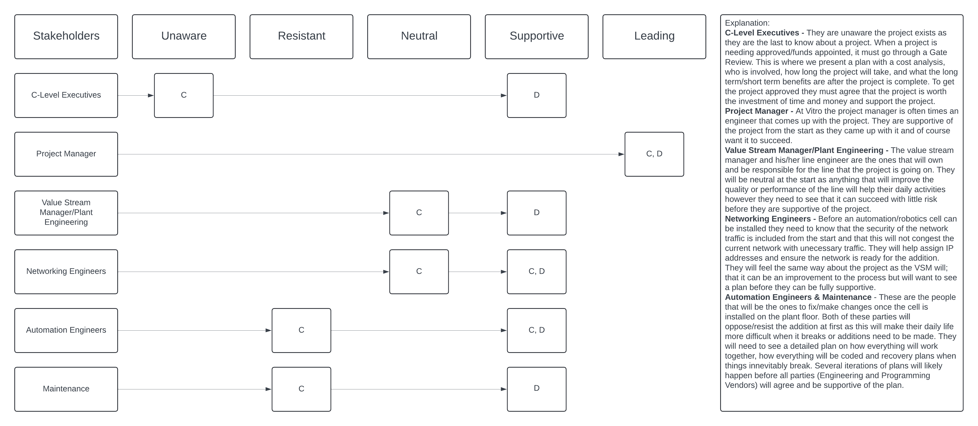
C-Level Executives - They are unaware the project exists as they are the last to know about a project. When a project is needing approved/funds appointed, it must go through a Gate Review. This is where we present a plan with a cost analysis, who is involved, how long the project will take, and what the long term/short term benefits are after the project is complete. To get the project approved they must agree that the project is worth the investment of time and money and support the project.
Project Manager - At Vitro the project manager is often an engineer that comes up with the project. They are supportive of the project from the start as they came up with it and of course want it to succeed.
Value Stream Manager/Plant Engineering - The value stream manager and his/her line engineer are the ones that will own and be responsible for the line that the project is going on. They will be neutral at the start as anything that will improve the quality or performance of the line will help their daily activities however, they need to see that it can succeed with little risk before they are supportive of the project.
Networking Engineers - Before an automation/robotics cell can be installed they need to know that the security of the network traffic is included from the start and that this will not congest the current network with unnecessary traffic. They will help assign IP addresses and ensure the network is ready for the addition. They will feel the same way about the project as the VSM will; that it can be an improvement to the process but will want to see a plan before they can be fully supportive.
Automation Engineers & Maintenance - These are the people that will be the ones to fix/make changes once the cell is installed on the plant floor. Both parties will oppose/resist the addition at first as this will make their daily life more difficult when it breaks or additions need to be made. They will need to see a detailed plan on how everything will work together, how everything will be coded and recovery plans when things inevitably break. Several iterations of plans will likely happen before all parties (Engineering and Programming Vendors) will agree and be supportive of the plan.
EHS – The Environmental Health and Safety manager would be involved for small portions of the project, specifically for ensuring that the project adheres to all safety regulations and concerns. They would also validate the safety measures during the installation at the end of the project timeline.
The Plan
Once all required articles have been submitted to the PM (Project Manager), he/she will then put a presentation together to propose during the Gate Review. At Vitro, the gate review is where you present to the highest stakeholders, the COO and subsequent management. Here they will decide on whether the project is worth investing in or if it is not. If they give the green light, then the project can continue and follow the following sections. If not, then the project is either not happening or needs further refinement.
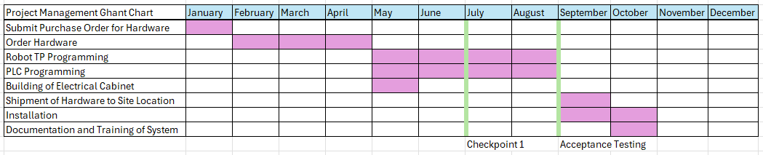
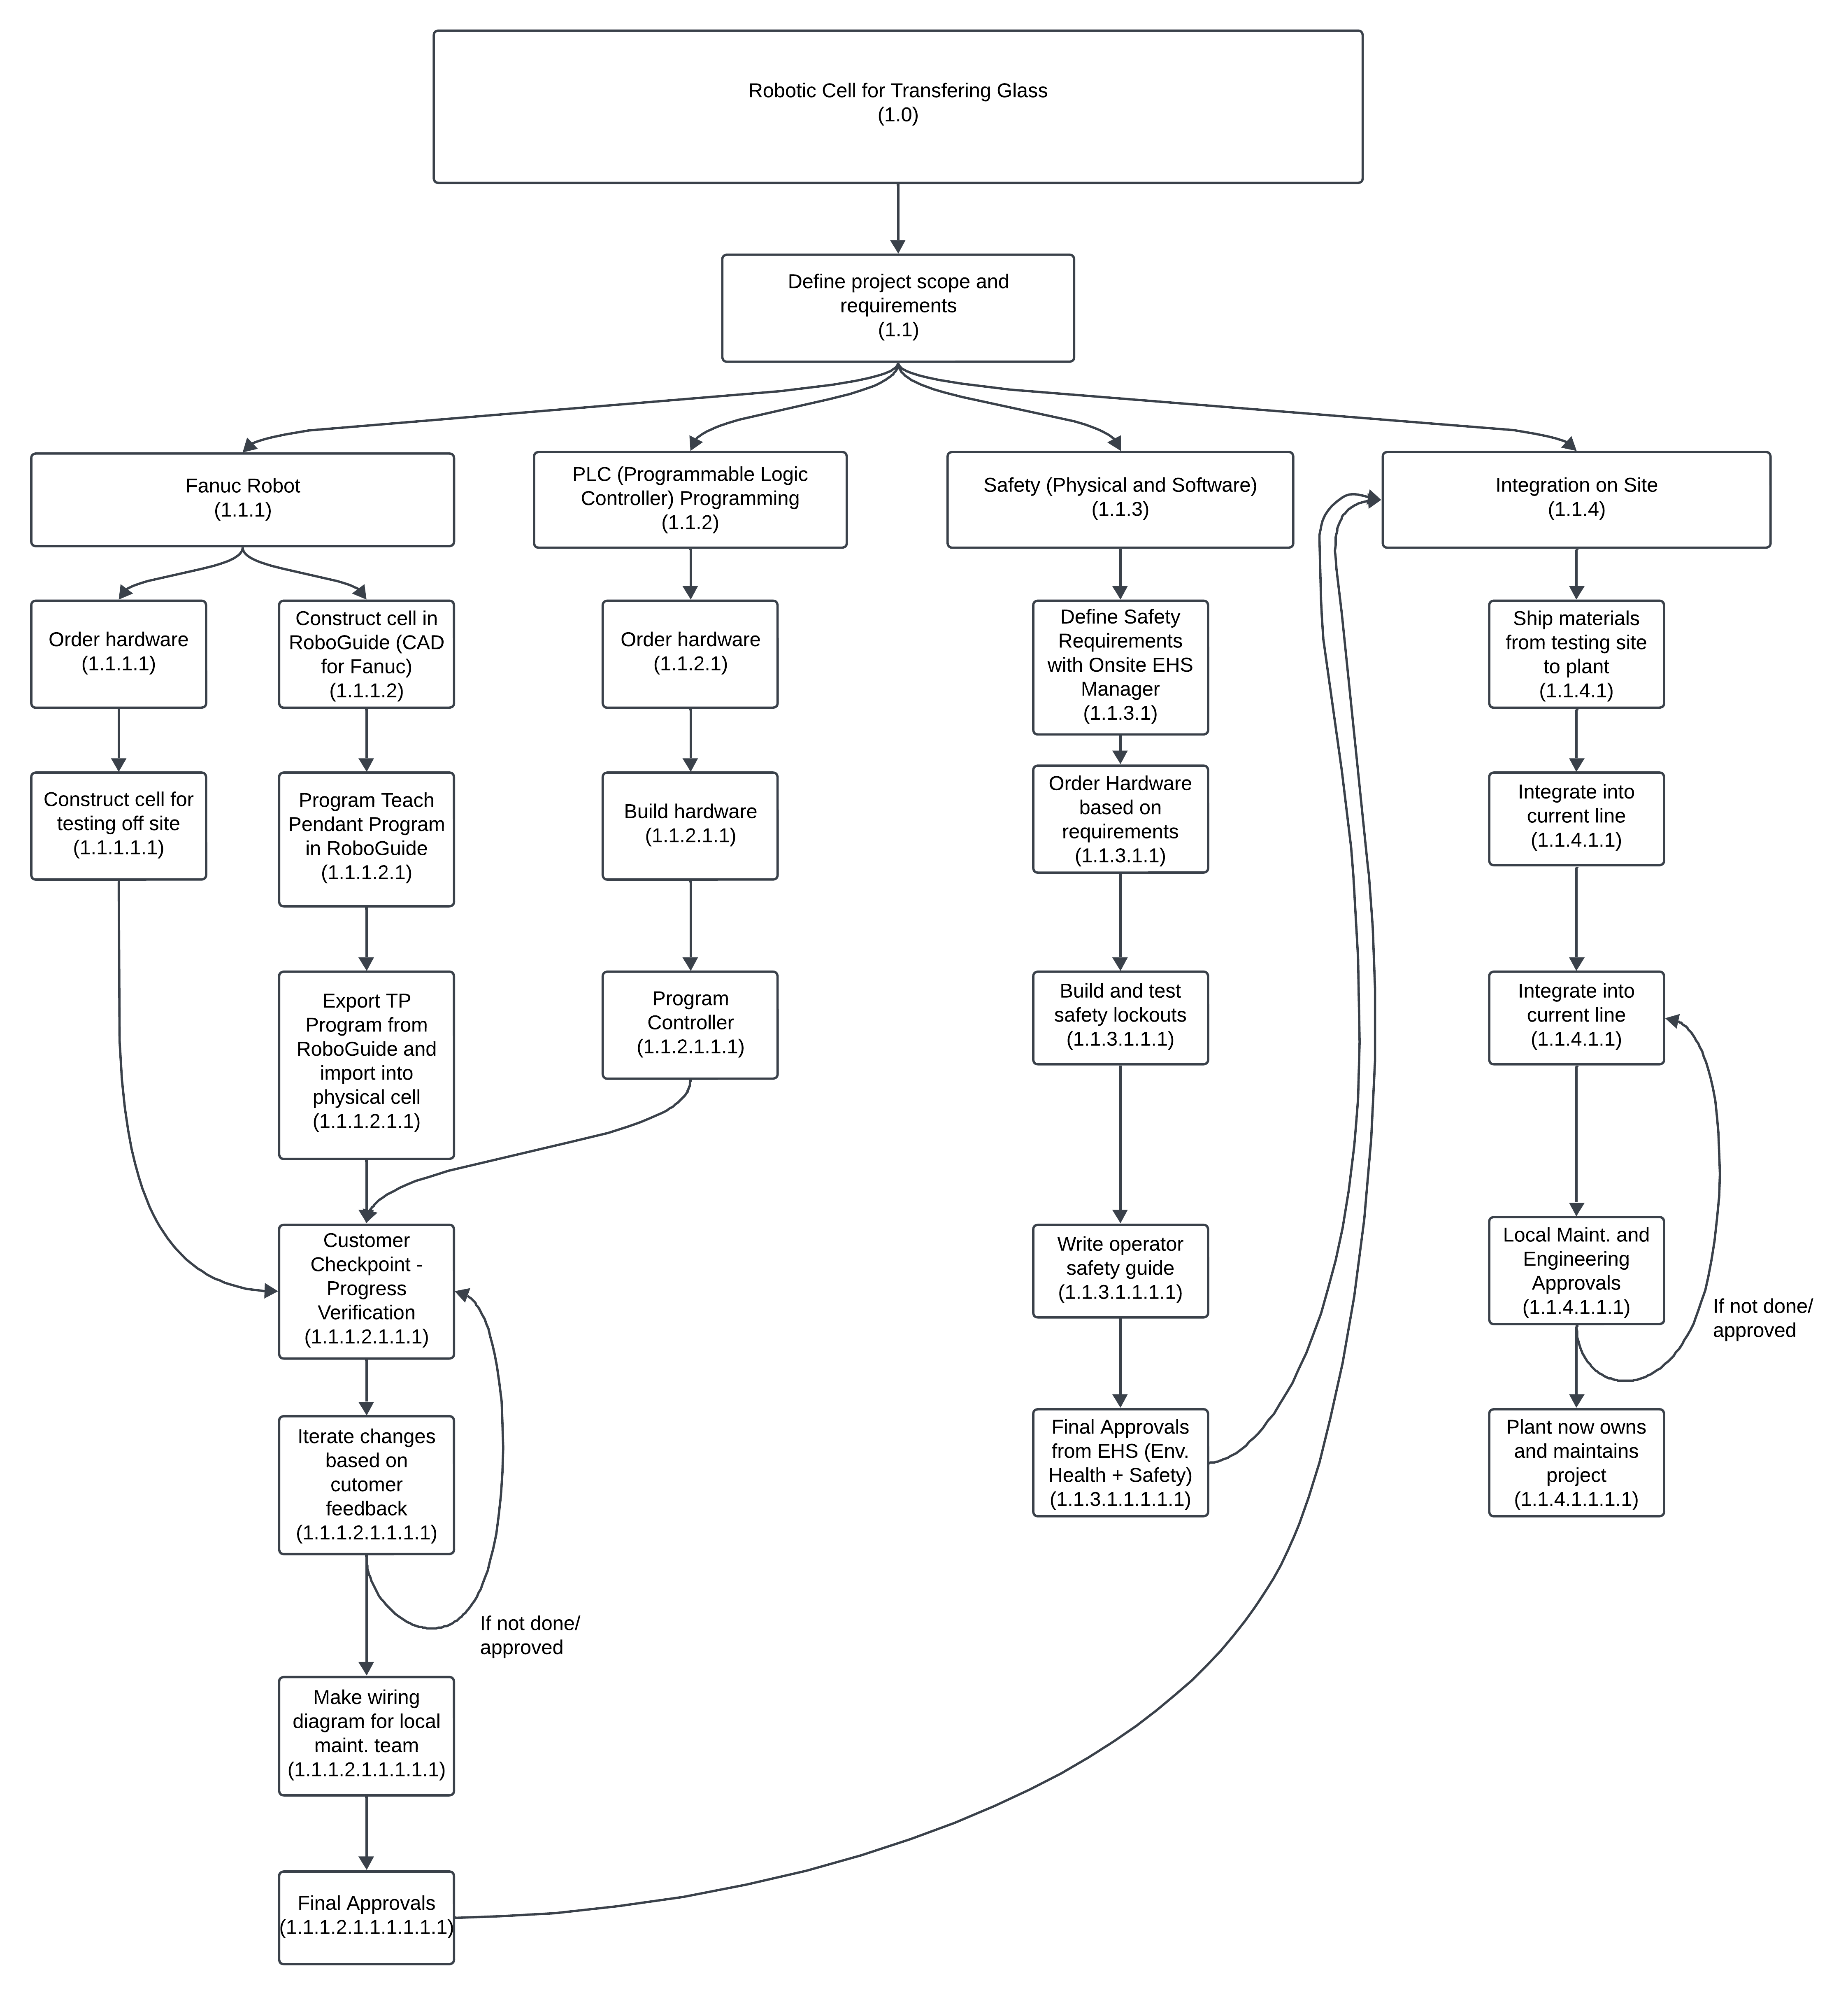
Due to the nature of this project and the work required to get everything approved. The best methodology would be Predictive rather than Adaptive or Agile methodologies. However, at the end of development, there will be some Agile methodologies which include iteration, review and repeat. In the images above, you will see the proposed timeline, scope of work, and workflow of how the project will be executed. The budget of the project was included in the bid article from the system integrator, which is $210,000 ($215,000 was the target budget during the bid sequence) with an approved budget of $250,000 which will then include $40,000 for contingency reserves due to unforeseen changes. These changes could include needing to modify the existing line further to ensure the new equipment fits or needing a small addition to the time needed to program and debug the cell during installation.
For this project there are 3 main areas of development with 1 final step for integration. For the Fanuc Robot and PLC step, as a customer, see the initial mockups of the cell in a program called RoboGuide. This allows them to build the cell and show us how it functions without physical hardware. At the same time the robot required and some materials to get started can be ordered in parallel as approvals can take a while to get. Once everything is constructed and built the programming of the physical hardware can commence. Testing of the hardware and programming can now happen. When the integrators are close to being done, we will go to their facility and do an acceptance testing of the machinery.
The checkpoint 1 test and acceptance testing are chances for both parties, the project manager, local stakeholders and the developers of the robot cell, a chance to align and make sure everything is still on track. It also allows for any changes to be made before being installed on-site. If any changes need to be made, we can adjust the timeline to account for the added time needed to make the change and a formal change request can be submitted which would include the time needed, additional costs, why the change is necessary and who is submitting the change. If any additional funds need to be allocated, then this information will be presented at an additional gate review for the additional funds to be released/not released. This is where the Agile methodology would come into play with iterations on production code, review of code and functionality and repeating the review process. These iterative steps are repeated as many times as it takes for all stakeholders to approve.
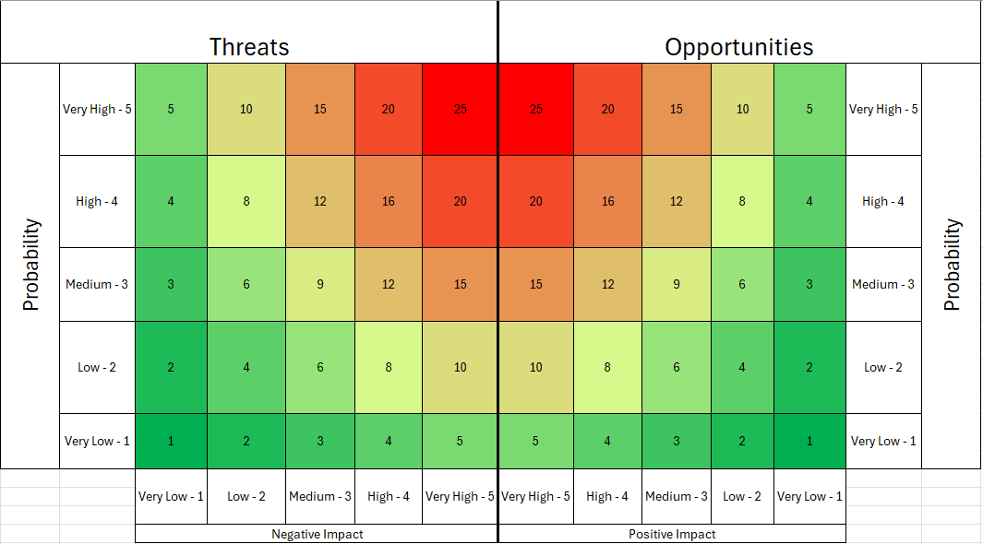
Top Risks
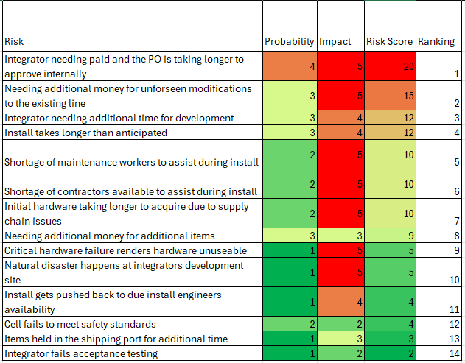
Addressing ranking number one, this has been an issue at Vitro for as long as I have been working on projects. The bureaucracy of everyone needing to approve the Purchase Order (P.O.) instead of just the people who need to definitely needs to change. This has the most likelihood of happening as it happens for almost every project. I’ve seen a project delayed due to this issue for 1-2 months because it is sitting in someone’s approval inbox and doesn’t do anything with it. This also has the highest impact as this could delay the entire project. Most integrators will not start working unless they have a down payment on the project and the rest is due upon installation. If they don’t get the initial payment in a timely manner, we could lose the spot for them to start programming and developing to a different project because the other project came through with their down payment. I have unfortunately seen this happen.
When a project comes to needing additional time and or money to complete can happen and is on average on the lower side. However, if they do happen it can cause the project to halt for a time and push back the timeline as we will need to present the project changes and why they happened at an additional gate review. This gate review includes all major decision-making stakeholders who can approve additional funds being released or not. Sometimes the integrators will continue and add it to the final bill, and some won’t until confirmation and proof of additional funds have been allocated to the project.
Natural disasters can happen but almost never occur to an extent that they interfere with a project. I say almost never because the COVID-19 virus during 2020 and 2021 did indeed disrupt everything from supply chain to working on projects at all. Hopefully, natural disasters continue to play a very small to non-existent role on projects.
The least likely and least impactful are based upon looking back at past projects. Even though they are least likely and the least impactful to the project doesn’t make them any less important to consider. Integrators are very good at making sure everyone is well protected and safe when working around and on robotic cells. Vitro also does a good job at making sure safety concerns are addressed from the start. Historically, items usually clear customs quickly and arrive at our facilities in a timely manner due to paperwork being filed correctly. Finally, even if an integrator fails to meet all criteria at acceptance testing, they are quick at turning around changes that will render the cell within all specifications.
Project Handoff
For these types of projects, the project never truly dies in a sense of completion. The initial project is completed when installation is complete. The project death occurs for the system integrator (for the most part). The system integrator may offer to remotely support the project if there is a service contract active. Vitro then has the responsibility of maintaining the robot cell for the lifetime of the cell. Any required maintenance or replacement parts needing purchased and installed will fall on Vitro, along with maintaining the supporting documentation. Supporting documentation will include a PM and scheduled maintenance timeline for all core components, a full parts list (which will include the name of the part, cost, vendor and frequency of replacement) which will help Vitro know which parts they would need to have on hand, a full stakeholder sign-off sheet for everyone’s records, and any other calibration hardware, documents or guides.
Process Improvements
Improvements to any kind of process is tough at Vitro due to the cultural barriers of Mexico and the U.S. Each change needs the same document with the same information sent to multiple people and even then, things may not change. Bureaucracy within Vitro is unfortunately quite high and can get in the way of improvements over “This is how it is because it has been done like this since the beginning”. Even if the improvements could save the company money in the long run. This goes for processes such as approvals, documentation, general support, project management, general maintenance and upkeep. With each project we try and implement what we have learned to avoid similar mistakes/pitfalls from happening but sometimes due to the stubborn people and bureaucracy they seem to happen more often than I would care to admit.
Conclusion
In conclusion, this paper guides the reader through the process of designing, planning and implementing robotic cells within the company Vitro Autoglass. To be this Project Manager you need to understand and have experience in each area within Vitro. These people are most likely people who have been within the company for many years or have been doing all these activities at some point in their career and are hired externally to drive the project. To be this kind of Project Manager, you must embody the “Swiss Army Knife” mentality.

References
- Pearson. (n.d.). Project Management Professional (PMP) Based on PMBOK7 (pp. 27–131). essay. Retrieved 2024, from https://www.ucertify.com/app/?func=ebook.

